Firebase pricing

The firebase pricing cannot be calculated or predicted before hand because it can be only be calculated once the app has been published  
   
Now after the app has been published, firebase is going to charge us in basically four main domains

1)the number of messages that have been sent to each other  
2)number of times data is written  
3)number of times data is read  
4)number of times data is deleted

Using the flexible methodologies that firebase provides we can easily check how much it is going to cost us at annual basis using the slider  
Firebase provides us with two basic plans for calculating the budget an individual app uses..  
The first plan is spark which is free to use..  
It is normally just a free trial for the user to see how the world of firebase actually works..  
  
The second plan is the blaze plan which we are currently using.  
The system how the blaze plan works is and if you would see there is a minimum threshold before which all the charges are free and once our chatbox functionality of the app crosses that threshold ,  
The app is charged with money which is not alot a huge amount as compared to other database services 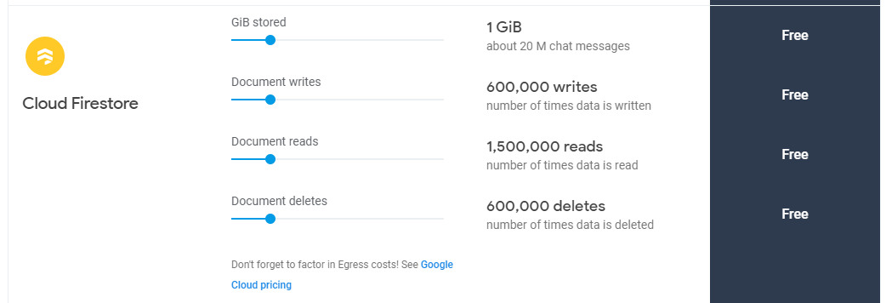

As you can see   
 Upto 20 million chat messages which occupy upto a gb of space is practically just free  
  
Upto 6,00,000 which is 6 lakh times the data can be written for free  
1,500,000 which is 15 lakh times the data can be read for free  
And upto 6 lakh times the data can be deleted just for free..  
Our app for a long time is just going to be handled by a free firebase server and after the threshold is crossed some amount of money would be required to pay which we have covered in the first presentation  
  
As far as the confidentiality of firebase is concerned we would like to show you the official pricing page of firebase and its immense trustworthy features   
  
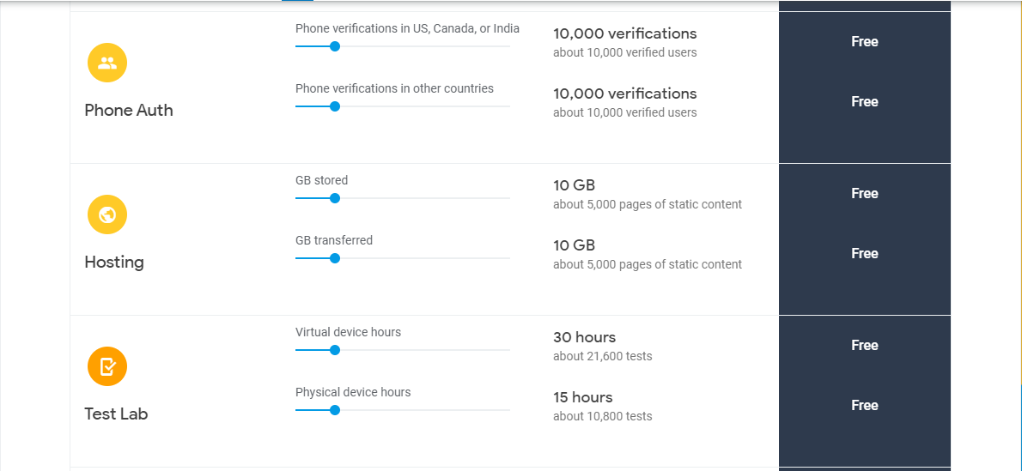  
  
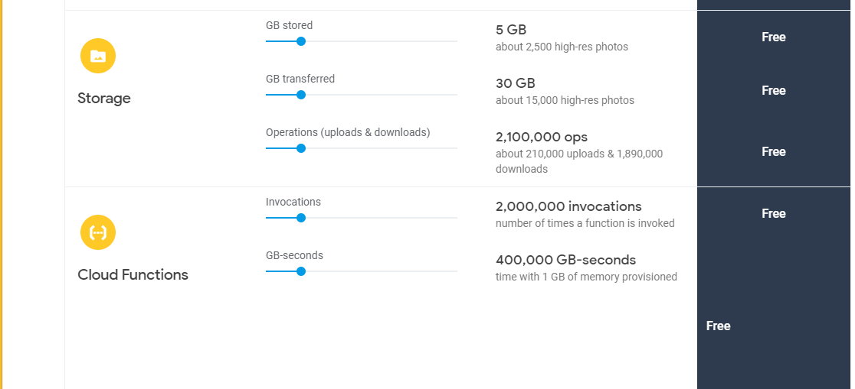

Firebase pricing faq sheet which we can use -

<https://firebase.google.com/support/faq#pricing>

--------------------------------------------------------------------

# **https://firebase.google.com/docs/firestore/quotas**

# **Firebase Authentication Limits**

The following auth operations have limitations on the frequency you can perform them. These limitations can change without notice. Contact Firebase support to discuss special use cases.

## **Account creation and deletion limits**

| **Operation** | **Limit** |
| --- | --- |
| New account creation | 100 accounts/IP address/hour |
| Account deletion | 10 accounts/second |

**Note:** You can schedule a temporary increase to the account creation limit in the Firebase console

## **Accounts per project**

| **Account type** | **Limit** |
| --- | --- |
| Anonymous user accounts | 100 million |
| Registered user accounts | Unlimited |

## **Email limits**

| **Operation** | **Spark plan limit** | **Flame and Blaze plan limit** |
| --- | --- | --- |
| Address verification emails | 1000 emails/day | 100,000 emails/day |
| Address change emails | 1000 emails/day | 10,000 emails/day |
| Password reset emails | 150 emails/day | 10,000 emails/day |
| Email link sign-in emails | 2000 emails/day | 25,000 emails/day |

## **Email link generation limits**

| **Operation** | **Spark plan limit** | **Flame and Blaze plan limit** |
| --- | --- | --- |
| Address verification links | 10,000 emails/day | 1,000,000 emails/day |
| Password reset links | 1500 emails/day | 100,000 emails/day |
| Sign-in links | 20,000 emails/day | 250,000 emails/day |

## **Phone number sign-in limits**

| **Operation** | **Limit** |
| --- | --- |
| User sign-ins | 1600/project/minute, as well as the pricing and limits specified on the [Pricing](https://firebase.google.com/pricing) page |
| Verification code SMS messages | 50 messages/IP address/minute, 500 messages/IP address/hour, 1500 messages/project/minute |
| Verification requests | 150 requests/IP address/hour |

## **API limits**

| **Operation** | **Limit** |
| --- | --- |
| Operations per service account | 500 requests/second |
| Operations per project | 1000 requests/second, 10 million requests/day |

## **Free quota**

Cloud Firestore offers free quota that allows you to get started at no cost. The free quota amounts are listed below. If you need more quota, you must [enable billing for your Cloud Platform project](https://cloud.google.com/billing/docs/how-to/modify-project).

Quotas are applied daily and reset around midnight Pacific time.

| **Free tier** | **Quota** |
| --- | --- |
| Stored data | 1 GiB |
| Document reads | 50,000 per day |
| Document writes | 20,000 per day |
| Document deletes | 20,000 per day |
| Network egress | 10 GiB per month |

**Firebase** is **free** for limited usages . The **free** version gives you 100 mb of data **storage** and a maximum of 50 connections .

Firebase has both 1 free and 2 subscription options:

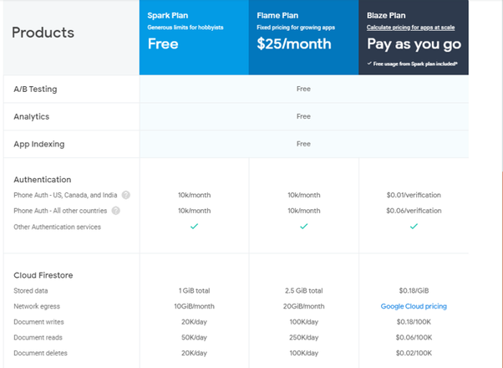

Firebase provides the best back-end server, great database and analytics solution, and useful integrations with other Google products. Most of all, users like that it’s free to use and has affordable subscription options. A wisely designed CMS solution guarantees project scalability and data security. In the development process, up to 40% of efforts are made on building a flexible CMS structure and Admin panel. So, if the features of Firebase Free plan are enough to achieve your final goal, then you may save up to 40% of your budget and also time.

This is a hypothetical situation

In which we have 500 new students for out app